

***FOUNDED MARCH 1971*** [***WWW.IRISHHISTORYROUNDTABLE.ORG***](http://WWW.IRISHHISTORYROUNDTABLE.ORG) ***October 2021***

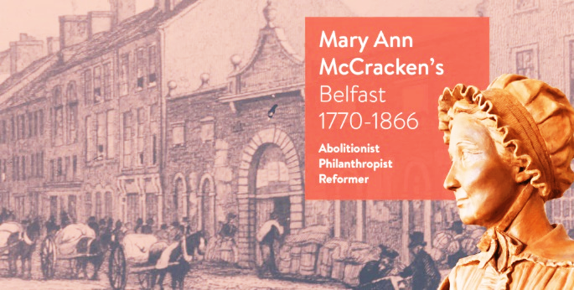Mary Ann McCracken, Irish Voice for the Voiceless

For our October 19th meeting of the IHRT, we have the pleasure of welcoming again , Peter Murphy. This time, Peter will give us insight into the productive life of an Irish patriot and committed humanitarian, Mary Ann McCracken. She has recently been given more notice than previously, and well deserved, as an abolitionist, reformer, and philanthropist of Ireland. Join us at 7:30pm for the latest update on all this history.

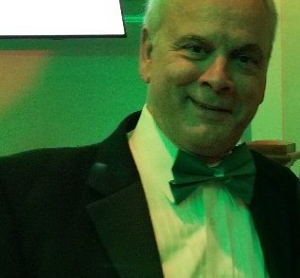Peter is a graduate of both UC, San Diego, and Trinity College. He has spoken at many conferences in Ireland, N.I., and in the United States on topics related to Irish history. During his lifetime, he has been deeply devoted to all things Irish. He is working on a biography of Robert Emmet’s brother, Thomas Addis Emmet (1764-1827).

**UPCOMING EVENTS**

* **Irish Memorial Bench, Oct.13th,12noon. Cheshire Linear Park. Contact: B. Larkin**
* **Wreath Ceremony, Oct. 30th, 11am, City Point, New Haven. Reception to follow. Contact: B. Larkin**
* **Rally for GHMuseum at QU . Oct. 30th , 1-5pm at the museum on Whitney Ave, Hamden**